**OXFORD ECOSYSTEMS LAB LEAF VEIN PROTOCOL (NOV 2016)**

**Developed with contributions from Benjamin Blonder, Agne Gvozdevaite, Norma Salinas, Miguel Jodra, and David Martini**

**Contact** [**bblonder@gmail.com**](mailto:bblonder@gmail.com) **with questions**

**Sample** **preparation**

Cut a 1 cm x 1 cm from the left side of the leaf. Avoid major veins. If the leaf is smaller, use the entire leaf. Place in a labelled cassette.

Some species have hairs, fuzz, granules or crystals on their surface that will get stained and obscure the veins, making analysis more difficult. If possible, it is advisable to remove these structures before the chemical processing to get better results and minimize the handling of digested samples. The samples should be flat and not too brittle.

You will need:

* Dissecting microscope.
* Sandpaper (P600 or P800 grit).
* Medium or soft bristles brush.

Always work under a dissecting microscope. Use a small piece of sandpaper to gently sand the surface of the sample, brushing away sanded material. Alternatively, you can just use the brush instead of the sandpaper.

**Chemical processing**

**Preparation**

1. Sodium hydroxide: 50 g of sodium hydroxide (NaOH) in 1 L of deionized water.
2. Water: 1 L of deionized water. Get fresh water every day and dispose after use.
3. Bleach: mix 250 mL of 10% sodium hypochlorite (NaClO) and 750 mL water (tap or deionized).
4. Ethanol/water: mix 500 mL of water (tap or deionized) and 500 mL of 100% ethanol.
5. Safranin: 1 g of safranin in 1 L of 100% ethanol. Change when it
6. Ethanol: 1 L of 100% ethanol.
7. Ethanol/toluene: mix 100 mL of 100% ethanol and 100 mL of 100% toluene.
8. Toluene: 200 mL of 100% toluene.

The proportions don’t need to be exact, so it is acceptable to measure liquids in a beaker and to round up or down (within reason) when weighing solids. Pour each solution (except for water, which should be renewed every time) into a different Pyrex dish of the appropriate size, cover with a lid and put a label on the dish (not the lid) with the name, composition and date of preparation of the solution.

**Protocol**

1. Put up to 20 cassettes in the Pyrex dish with the NaOH solution. Cover with the lid and leave on the hot plate at 60°C (around setting #1 on the hot plate)*.* Most samples will be ready after 2-3 days, but thin ones will just take 1 day and others can take longer than 3 days, so check daily one by one by opening the cassettes.  
     
   The samples are ready when are transparent. If available, a dissecting microscope can help to decide when they are ready. If undecided and the sample looks in good condition, leave it for one more day.  
     
   The NaOH solution should be changed as it loses strength. Change it if the clearing does not appear to be progressing from one day to the next, or when the solution becomes dark or cloudy.
2. Use tweezers to transfer all the samples that are ready to the dish with water. Tilt the dish to wash the leaves.
3. Transfer the samples from the water to the bleach solution and leave them for 5 minutes or longer (no more than 30 minutes). The samples are ready when they become white. Leaving the samples for too long in this solution can destroy them.
4. Transfer the samples from the bleach back to the water to wash out the bleach.
5. Transfer the samples to the 50% ethanol/water solution. Leave for at least 1 minute and tilt the samples to ensure the samples are saturated. Keep the dish covered as the ethanol will evaporate quickly. Change the solution if the level drops*.*
6. Quickly transfer the samples to the safranin-ethanol solution. Leave the samples for about 4-5 minutes and transfer to the dish with pure ethanol. Some samples may take longer to stain.

When all the samples are in the pure ethanol check them one by one to see if they stained homogeneously. Samples that are not stained enough can be re-stained. When moving the samples,make sure that the ethanol does not fully evaporate from them*.*

1. Leave the samples to destain in the dish with pure ethanol for about 30 minutes. Longer periods are usually not harmful. If the ethanol is fresh, the destaining process could go faster. In this case 15 minutes may be enough.While the samples are destaining, prepare the labelled glass slides and put them on a Pyrex dish lid (or similar) covered with paper, in the same order as the samples.
2. Transfer the samples (up to 6 at a time) to 50% ethanol/toluene solution and leave them for at least 1-2 minutes.
3. Quickly transfer the samples to the pure toluene solution and leave for at least 1 minute (longer times are not harmful). Never allow the toluene to evaporate completely from the sample.

Change the toluene when it starts to stain the mounting medium (it will be dark pink/red). Always change the toluene and the ethanol/toluene solution at the same time.

1. Put some drops of mounting medium on the centre of the glass slide and spread with a coffee stirrer to the approximate size of a cover glass.
2. Pick up a cassette, open it and take the sample with the tweezers. Re-immerge the sample in the toluene (to minimize toluene evaporation during mounting) and quickly put it on top of the mounting medium.
3. Quickly put a few drops of mounting medium onto the sample. Do not spread as it will introduce air bubbles.
4. Take a cover glass, hold it with the tweezers from one edge, and gently let it fall on the sample starting from one side. Very gently, push the cover glass down to help spread the mounting medium, push air bubbles to the edge and make the sample flat against the slide.

The mounting medium should take up the whole space of the cover glass, since it will shrink as it dries, potentially ruining the sample. If some pockets of air are present you can fill them with mounting medium from the sides.

1. Let the samples to dry in the fume cupboard for at least two days before storing them in a box.

**Aftercare**

After mounting, leave the samples to dry for a few days before putting them in a slide box. During this time, check them occasionally for bubbles. Air bubbles that appear at the edge of the coverslip will grow as the mounting medium dries and they can grow over the sample, ruining it. This can be solved by carefully applying more mounting medium at the edge where bubbles have appeared, which will seal them and keep them from growing.

Excess mounting medium that ends up over the cover glass can be carefully removed with a knife after it dries.

**Removing the cuticle/epidermis**

Some species will fail to clear completely with the usual chemical treatment. If you decide to redo those, you can try to remove the cuticle and/or epidermis so the veins can be seen more clearly. This is a very invasive and time-consuming procedure, so it may not be advisable in all cases. You will need:

* Dissecting microscope.
* Cheap, synthetic bristle brush.
* Fine point tweezers.
* Glass slide and water.

After the samples have been softened by the sodium hydroxide, carefully take the sample from the cassette and place it on a glass slide using the brush or the tweezers. Under the microscope, brush the sample gently and with short, slow strokes using a brush wet with water.

Try brushing on one small corner before applying the treatment to the whole sample. Use this to check for damage and to decide which side of the sample should be brushed (typically, only one side of the sample needs to be).

If a flap of cuticle is lifted, you can use the tweezers to remove it, being careful not to damage any veins.

In some cases, it is better to softly tap on the sample with the brush, instead of stroking it. If the cuticle is soft enough, this can break it into small pieces that can be removed with the tweezers or washed away with water, leaving the intact veins behind.

Always work under the dissecting microscope, and never use the brush on a portion of the sample out of the field of view, to avoid inadvertently damaging the sample.

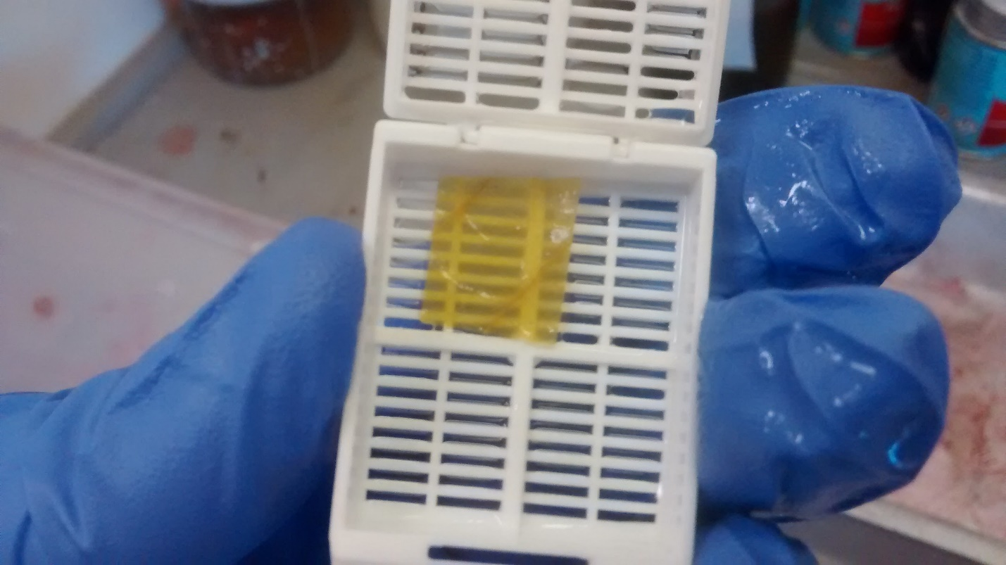

Figure1: After 3 days in NaOH the sample is ready (transparent)

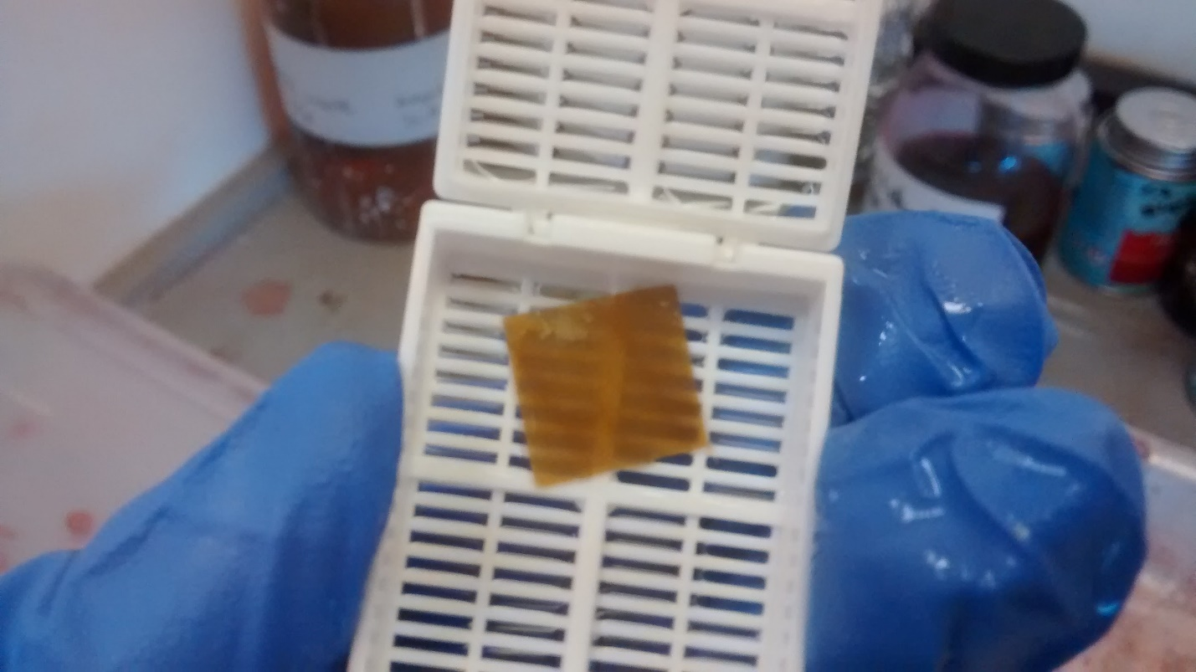

Figure 2: The sample is not ready and needs more days in NaOH (not transparent enough)

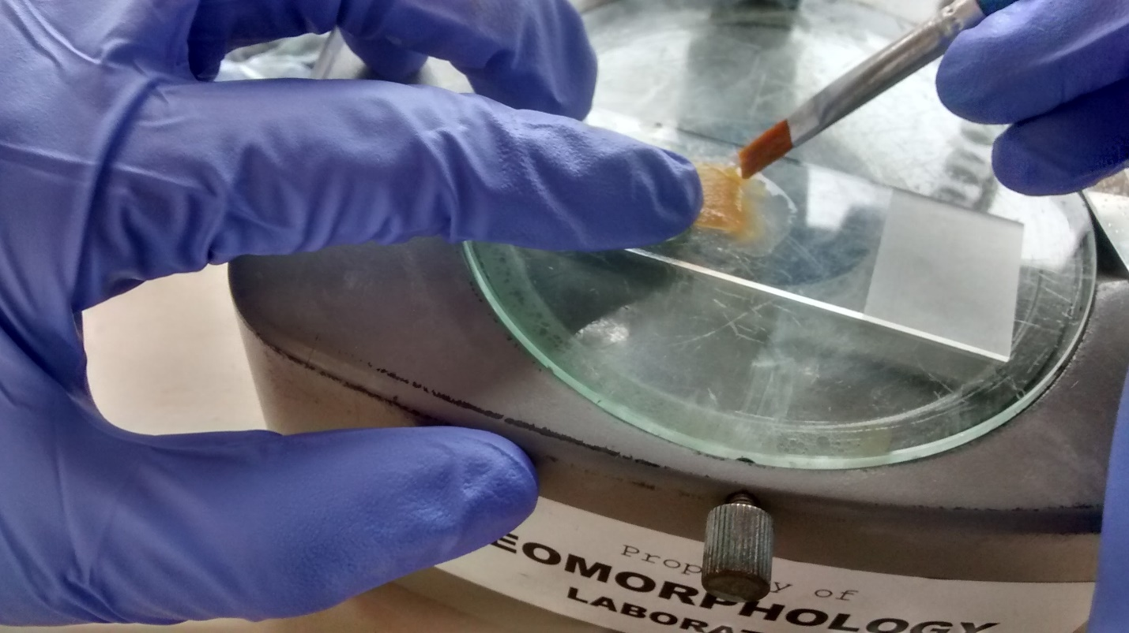

Figure 3: How to brush

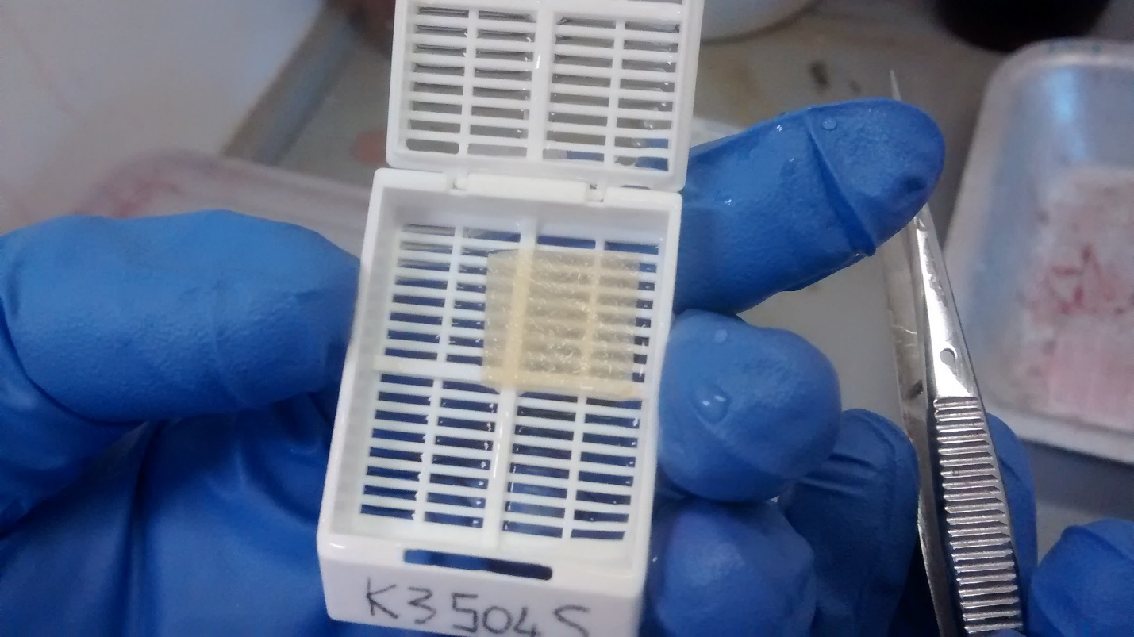

Figure 4: After 20 minutes in bleach the sample is ready